**R Basic Workshop**

Section 1 Foundations for R (around 30 mins)

1.1 R basic: the interface of R

1.2 Basic Classes of Objects in R

1.3 Data Types in R

1.4 Basic Computations in R

1.5 Control Structures in R *

Section 2 Practices of Data Processing by R (around 1 hour)

2.1 Importing Data and Installing R packages

2.2 Basic Operations before staring data processing

2.3 Important Packages for Data Preparation

2.4 Important Packages for Data Visualization

2.5 Suggestions for using R in practice

Important:

Please download and install R and R studio before the R Basic Workshop based on the following instructions:

***For R:***

1. Go to [*https://www.r-project.org/*](https://www.r-project.org/)and click “To download R” (as shown below);

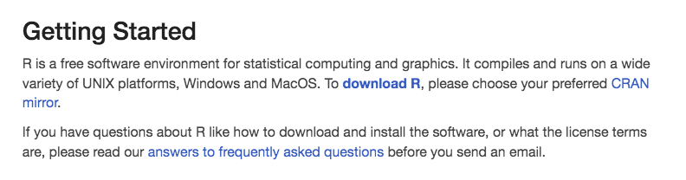

2. Choose one of the shown locations you like and click;

3. Download the version that works for your computer. It has versions for MAC, Windows and Linux

4. Install it and you finish this step!

***For R studio:***

1. Go to [*https://rstudio.com/products/rstudio/download/#download*](https://rstudio.com/products/rstudio/download/#download)

2. In ‘Installers for Supported Platforms’ section, choose and click the R Studio installer based on your operating system. The download should begin as soon as you click

3. Install it. (just click next and you can do it! ☺)

Now you are ready for writing and running R codes! Congratulations! Some datasets will be sent to you via Dropbox links after your registration as the teaching materials. Please make sure you download the dataset as well.

Looking forward to seeing you next Wednesday!